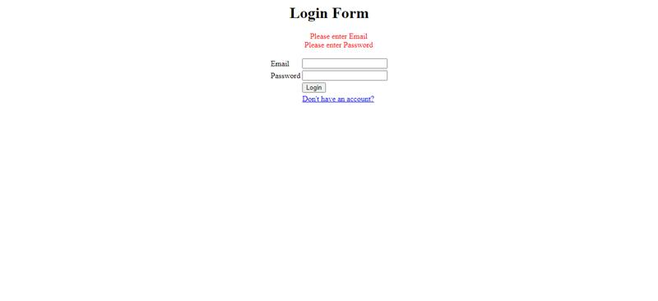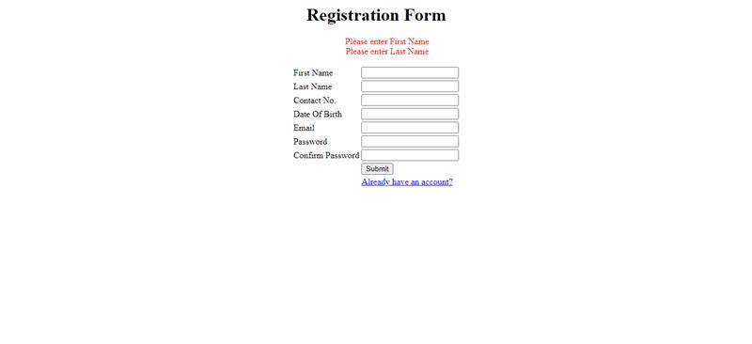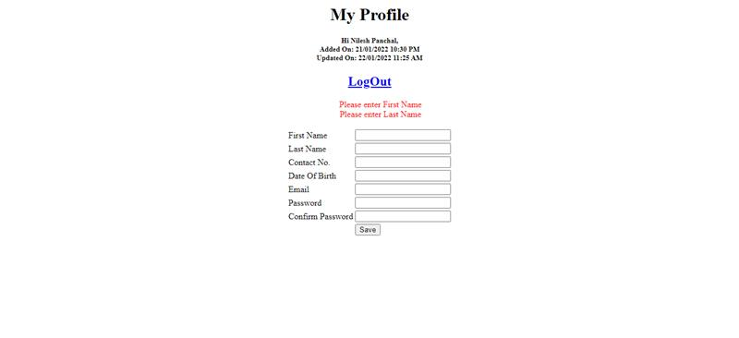

**Customer Registration & Login Assignment**

**User Registration Page**  
+++  
- Create user registration form with below fields  
First Name  
Last Name  
Contact No.  
Date Of Birth (You can use jQuery Date Picker)  
Email  
Password (Entered value will be displayed as *(Star) or .(dot))  
Confirm Password (Entered value will be displayed as *(Star) or .(dot))  
  
1) Below are mandatory fields  
- First Name, Contact No., Email, Password, Confirm Password  
  
- Contact No. should be only numeric  
- Email should be in valid format  
- Date Of Birth format should be DD/MM/YYYY  
- Password must contains below,  
* special character  
* Alpha numeric  
* Minimum length 8  
* Maximum length 12  
- Password & Confirm Password should be same.  
- After submitting form, All the details are stored in Users table in database.  
- Once User details stored in database, Page will be redirect to Login Page and below message will be display on login page.  
- You are Registered successfully, You can login with your Email & Password.  
- Keep Login page link on Registration page.

**Login Page**  
+++  
- Create user login form with Email and Password fields. (Email and Password both are mandatory fields)  
- Validate the user after submitting email and password details from Login page.  
- If Email and Password are matched with registered user's details, then page will be redirected to My Profile Page.  
- If Email and Password are not matched with any registered user's details, the Error message should be display on Login Form.  
- Keep Registration page link on Login page.

**My Profile Page**  
+++  
- Well-come message will displayed as below .  
Hi Nilesh Panchal,  
Added On: 21/01/2022 10:30 PM  
Updated On: 22/01/2022 11:25 AM  
  
Format  
++  
Hi [First Name][Space][Last Name],  
Added On: [User registered date in DD/MM/YYYY HH:MM AM/PM Format]  
Updated On: [User updated date in DD/MM/YYYY HH:MM AM/PM Format]  
  
- There will be a form with below fields  
First Name  
Last Name  
Contact No.  
Date Of Birth  
Email  
Password  
Confirm Password  
- User can update his/her details from here.  
- User Password should not be changed, If User not filled password & Confirm Password while update.  
- All fields value are populated with logged user details excluding Password & Confirm Password.  
- All fields will be validate same as Registration page Excluding Password & Confirm Password.  
- Password & Confirm Password are conditionally mandatory fields. If user filled value in any fields, then both fields are mandatory. Also Password format will be same as registration page.  
- If user updated details, Below will be displayed on same page.  
* Your details are successfully.  
- Keep Logout button in My Profile page. When user click on Logout button, then user will be logged out from system and page will be redirected to Login page with below message.  
* You Logged out successfully.  
  
  
Note:  
- All naming convention will be followed in assignment.  
- Use JavaScript/jQuery to validate all the fields.  
- Keep * after label for all mandatory fields.  
- All JavaScript validation messages will display same time.  
- Do not use HTML date picker for Date Of Birth field.  
- Use Session or Cookie to maintain the user login.  
- When user register, User registered date time will save in database table.  
- When user update the details, User updated date time will save in database table.

- Customer details needs to store in encryption format in database

Database table structure  
recid bigint(20)  
firstname varchar(255)  
lastname varchar(255)  
contactno varchar(255)  
dateofbirth date  
email varchar(255)  
password varchar(255)  
dateadded datetime  
lastupdated datetime  
endeffdt date